Emysys’ Analysis and

Process Improvements

1. **Business and Enterprise Analysis** **4**

1.1 Research for Enterprise 4

1.1.1. Industry Segment 4

1.1.2. Products and Services 4

1.1.3. Market 4

1.1.4. Business and Organizational Structure 4

1.1.5. Value Chain 4

1.1.6. Stated Areas of Differentiation 5

1.2. Analysis 5

1.2.1. 5-Force Analysis 5

1.2.2. Differentiation vs Competitive Competition 6

1.2.3. Balanced Scorecards 6

1.3. Software Portfolio 8

1.3.1 Marketing & Sales 8

1.3.2 Services 8

1.3.3 Application to Develop Further 9

2. **Intended Software Engineering Process** **10**

2.1. Spider Diagram 10

2.1.1 Personnel 10

2.1.2 Dynamism 10

2.1.3. Culture 10

2.1.4. Size 10

2.1.5. Criticality 11

2.2. Project Management 11

2.2.1. Release Plan 11

2.2.2. Iteration Plan 11

2.2.3. Risk Plan 11

2.2.4. Linear and Parametric Estimation 12

2.2.5. Project Schedule 12

2.3. Requirements 12

2.3.1. Storyboards 12

2.3.2. Problem Statement 12

2.3.3. Business Case 12

2.3.4. Use Cases 13

2.3.5.User Stories 13

2.3.6. Scenarios 13

2.3.7. Nonfunctional Requirements 13

2.3.8. Acceptance Plan 13

2.3.9. System Tests 13

2.4. Analysis 13

2.4.1. Domain Analysis 13

2.4.2. Problem Analysis 14

2.4.3. Solution Analysis 14

2.4.4. Sequence Diagrams 14

2.4.5. Collaboration Diagrams 14

2.5. Architecture 14

2.5.1. Subsystem Model 14

2.5.2. Target Environment 14

2.5.3. System Architecture 14

3. **Requirements Analysis** **15**

3.1. Problem Statement 15

3.2. Problem Analysis 15

3.3. Business Case 16

3.3.1. Costs 16

3.3.2. Benefits 16

3.4. Solution Analysis 17

3.4.1. Class Diagram for GeoSpatial Analysis 17

3.4.2. Static Structure 18

3.4.3. Dynamic Behavior 18

3.4.4. Sequence Diagram of How Geolocation Analytics Works 18

3.5. Storyboard 19

3.6. Functional Requirements 20

3.7. Actors 20

3.8. Use Cases, Scenarios, User Stories 21

3.9. Use Cases, Scenarios, User Stories 24

3.10. Non-Functional Requirements 25

3.11. Acceptance Plan 26

4. **Architecture** **28**

4.1. Overview 28

4.2. Subsystem Model 28

4.3. Target Environment 33

4.3.1. Deployment Diagram 33

4.3.2. Explanation of Components in Deployment Diagram 33

5. **Project Planning** **38**

5.1. Release Plan 38

5.2. Project Estimation 38

5.2.1. Linear Estimate 38

5.2.2. Use Case Points Estimate 39

5.2.3. Comparison 42

5.3. Project Schedule 43

5.4. First Release 43

5.5. Risk Management Plan 44

# **Business and Enterprise Analysis**

## **Research for Enterprise**

### **Industry Segment**

* + - * Forestry Industry
      * Platform for predicting wildfire behavior
      * Platform is freely available on the internet as a web application

### **Products and Services**

* + - * 3D aerial imagery, topographical maps, or street maps
      * Campbell Prediction System (CPS) “alignment of forces” information
        + Collection of stories and information regarding wildfire situations
        + Doug Campbell had 30 years of wildfire experience and 10 years of course development experience
      * Observe fire spread computations
      * Simplified graphics to explain fire environment and fire behavior
      * Animates the paths the fire would take through terrains

### **Market**

* + - * First responders and dispatchers in locations in which wildfires occur
      * Residents of areas that have an increased risk of wildfires occurring
      * Investors in the forest market industry
      * Forest scientists
      * Land managers
      * Home owners

### **Business and Organizational Structure**

* + - * Software Development and Consulting Business
      * Free software developed by Bruce Schubert
      * Open source software

### **Value Chain**

* + - * Inbound Logistics
        + Fire behavior analysts send fire signature, weather, environment, and fire perimeter information to the CPS
        + VMS Map Servers send Terrain Imagery and elevation to the CPS
        + USGS Landfire servers send Fuel model and vegetation layer data to CPS
        + The Fire History database sends fire signature records
      * Operations
        + The CPS aggregates all of the given data detailed in the Inbound Logistics section and calculates the desired information
      * Outbound Logistics
        + Sends potential fire behavior, trigger points, and IAP maps to Operations Personnel
        + Sends a fire signature update to the Fire History Database
      * Marketing and Sales
        + Open Source Developers
        + Wildland Firefighters
        + Fire Management Personnel
      * Services
        + Open Source Development for improving the product
        + Through open source development, the product is made free to consumers

### **Stated Areas of Differentiation**

* + - * Open source allows addition of features that can happen much faster than individual companies by having a wide variety of influences
      * The creator of the software provides information on the prediction system and extensive documentation on all of the features to help users understand
      * There are various test scenarios and features to help users explore the platform

## **Analysis**

### **5-Force Analysis**

* + - * Bargaining Power of Customers
        + Low bargaining power of customers since there aren’t many alternatives
        + Less price sensitive since the impact of stopping wildfires is tremendously high
        + Buyer power is less because buyers are not cost sensitive since the software is free
      * Threat of Substitute Product
        + Threat exists due to other software existing, some open source and some paid
        + Lower propensity to switch software due to learning curve
        + Switching cost could be higher since Emxsys is free
      * Bargaining Power of Suppliers
        + High bargaining power due to limited amount of software available
        + Importance of volume is low due to software being free
        + High bargaining power due to cost of users switching can be high due to price difference and learning curve of software
      * Threat of New Entrants
        + Lower threat of new entrants due to current users of Emxsys software are less likely to switch products since the first responders and targeted audience of the software is likely less tech-savvy so the audience is less likely to learn new software. The target audience is also likely to want to stick to how things have always been done.
      * Competitive Rivalry
        + The CPS system Emxsys uses is unique so competitors are less likely to use it.
        + Emxsys plans on developing instructors in fire agencies to use their methods so users are likely to be loyal with the software.

### **Differentiation vs Competitive Competition**

Emxsys’s strategy of differentiation is justified by its current competitive position because of its status as a unique tool in the emergency management and forestry industry. Its use of the CPS system and innovative approach to fire prediction as well as its open source model gives Emxsys a competitive edge by being a unique product with a low cost to entry.

### **Balanced Scorecards**

|  |  |  |  |  |
| --- | --- | --- | --- | --- |
| Theme:  Marketing & Sales | Objectives | Measures | Targets | Initiatives |
| Financial | Increase profits  More customers purchase the software | Comparing annual profit year by year | 100% profit increase for the first year from sales | Sell to government agencies |
| Customer | Customer can ensure a consistent and well kept product | Customer satisfaction survey  Customer growth year-to-year | 90% customer satisfaction  50% annual growth each year | Follow the current standards for software development in order to have easy platform usage |
| Internal Business Processes | Build software development team | Number of developers on the software team | At least 10 developers on the team | Target significant open source contributors |
| Learning & Growth | Learn how to take the open source program to for-profit | The % of the entire program that can be made for-profit | 100% of the program switched to for-profit | Compensate open source contributors fairly for their work |

Linking:

* Learning & Growth: The team will need to learn the process and how to take the platform from being an open source program and turn it into a for-profit product.
* Internal Business Processes: This knowledge will allow the team to start building up a software development team in order to continuously develop the software and produce the best program.
* Customer: Due to having an consistently updated and easy-using software, the product is very marketable to customers looking for software attempting to aid in wildfire analysis and prevention.
* Financial: Having an increase in the amount of customers will increase the revenue and profit for the company, and, due to the success of the product, other customers and government agencies will have interest in this software as well.

|  |  |  |  |  |
| --- | --- | --- | --- | --- |
| Theme:  Services | Objectives | Measures | Targets | Initiatives |
| Financial | Increase profits  Increase Retention | Comparing annual revenue year by year  Compare annual retention for customers | 100% profit increase for the first year  Gain more customers than lost | Sell to government agencies |
| Customer | Customer can reach out to customer service team with various questions | Monitor number of customer questions  Create feature if numerous customers are asking | Respond to 100% of customer questions  Create the features customers are asking for | Give awards / incentives to customers for using the team |
| Internal Business Processes | Create Customer Service team / platform | Have a dedicated team for answering customers | 5 employees on the team by the end of the first year | Pay competitive wage for the position |
| Learning & Growth | Increase knowledge of the platform by everyone in the company | Complete training for background and basic usage of the program | 90% of employees complete the training | Give employees small bonus for completion of program |

Linking:

* + - * Learning & Growth: The team will need to understand the basic usage of the platform in order to aid in helping customers out.
      * Internal Business Processes: Using this knowledge, a customer service team will be created to interact with customers to discuss their needs and wants.
      * Customer: The customer will directly contact the customer service team who will help answer any questions and log any issues that cannot be solved by the current application.
      * Financial: By having a customer service team, customers will be happier because they will feel wanted. Their questions will be answered and their wants will be considered. These wants (by the people actually using the platform) will help push the application forward with consistent updates that will be very beneficial.

## **Software Portfolio**

In order to successfully implement the changes discussed using the balanced scorecards, new software applications will need to be created. These new applications will aid the company by promoting growth, increasing revenue, nurturing customer satisfaction, and expanding the features of the application itself.

### **Marketing & Sales**

* + - * Geolocation Analytics Tool
        + This feature would be run internally, and it would leverage the platform as well as the CPS in order to proactively predict future wildfires and any potential disaster situations. Using this tool, the company would be able to inform the local authorities about the possibility of a disaster and attempt to sell or license the product to help control the impending wildfire.
      * User Demographic Tool
        + This feature would take data regarding the users of the platform. It will help analyze the “typical user”. Using this information, the company will then be able to better identify potential customers and reach out to the customers themselves, rather than waiting for customers to reach out to the company.

### **Services**

* + - * Customer Service Hub
        + This application would be used to provide a portal for customers to contact customer support, ask questions, see FAQs and previously asked questions. This would provide customers with an appropriate outlet to address any concerns and seek support.
      * Tutorial Tool
        + This tool would serve to provide users with tutorials on how to use the software as well as give explanations on how CPS works as well as the many terms associated with CPS. This tool would help reduce the hurdle associated with learning about the CPS system so that customers would have an easier time integrating with the software and employees could use these tutorials to better learn about the service themselves as well as refer customers to them.

### **Application to Develop Further**

The application that would be the most beneficial to develop further would be the Geolocation Analytics Tool. This application would be an easy extension of the current application, which provides the company a relatively immediate solution for cash flow. By configuring the ability to run the application in the background and identifying the necessary authorities to alert, the product will show the accuracy of the CPS and how essential the product is for these areas that are impacted by wildfires. Thus, creating a demand for the product by companies and government organizations.

# **Intended Software Engineering Process**

## **Spider Diagram**

The below spider diagram illustrates the team’s thoughts on Emxsys’s current company outlook and its software systems, as well as the team’s belief in the project and its necessary features needed for development.

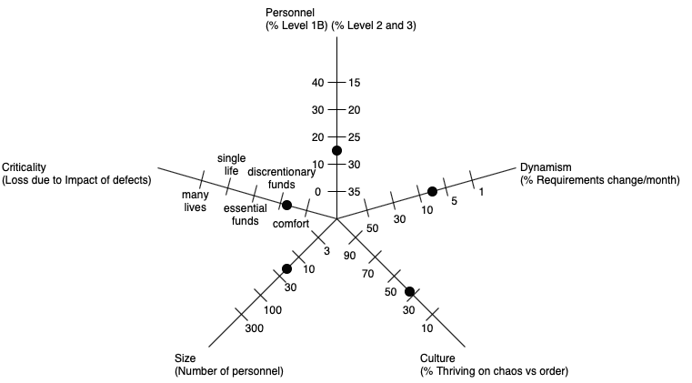

### **Personnel**

Since Emxsys uses the Campbell Prediction System, the basic algorithms are already implemented. Thus, the features that would need to be implemented are fairly trivial, which makes the need for top-tier employees much less than having to reimplement the algorithms.

### **Dynamism**

The project the team is trying to implement is well documented in the previous section, and it would only need relatively small modifications as the project is being developed.

### **Culture**

There are no defined culture standards for Emxsys since it is open sourced currently, and the nature of the platform will cause hesitation to make dramatic changes. So, the culture would tend to be more orderly rather than chaotic.

### **Size**

Emxsys is open-sourced, and it does not have paid employees constantly updating the system. Also, the features that are suggested by the team are numerous and quite sizable. Thus, the number of personnel needed would need to be increased semi-dramatically.

### **Criticality**

While the nature of the system deals with wildfires and many lives are at stake, the algorithms to predict the wildfires are already in place. The solution the team is proposing will be focused mainly on customer service and geographical analytic systems. Therefore, the criticality is closer to discretionary funds, rather than being towards the higher end of the criticality spectrum.

## **Project Management**

Project management is and will be an ongoing process throughout the SDLC for the team. However, an initial outlook on the team’s plan is detailed below.

### **Release Plan**

The current release plan is uncertain. However, through domain analysis and gathering of various information, a clearer picture will develop, in which, a rough estimation of an inceptive release plan will be developed. As the project gathers traction and the most necessary features are decided upon by the team, these will be prioritized in order to complete a minimum viable product (MVP), with the less important features as an extension for a more complete product.

### **Iteration Plan**

Once the release plan has been developed, it will be divided into various iterations. In each iteration, a comprehensible list of user stories, use cases, functional and nonfunctional requirements will be detailed.

### **Risk Plan**

As with any endeavor, there are numerous risks that will occur throughout its lifetime. The team will attempt to stay ahead of these issues by outlining potential risks, how each might occur, the necessary mitigation steps, the proper way of detailing new risks, and how to document the completion of these issues.

### **Linear and Parametric Estimation**

The team will use Scrum methodology to assist in breaking down the project. The use of a product backlog will allow the team to get an overview of all the features that will need to be completed. The product backlog will be broken up by numerous sprints categorized by major topics. Each item in the product backlog (and sprint backlogs) will be given a value based on difficulty. The values will be: 1, 2, 3, 5, 8, 13. Using values based on difficulty rather than hours will provide a much more accurate estimation so that the sprints can be accurately distributed and planned for.

### **Project Schedule**

The project schedule will be a visual representation of a timeline, and it will be created following the completion of the iteration plan. This will allow the team to have an accurate and encompassing breadth of the project. Therefore, the sprints can be distributed evenly, and it will allow the team to understand how long the project will take to deliver a proper project schedule.

## **Requirements**

The team will need to gather all necessary requirements and information regarding the project to give the following work products real meaning. Once this is done, the team will document, detail, and analyze which are of the utmost importance to the project.

### **Storyboards**

Storyboards will be used in order to give a visual representation of the system. This will provide aid to developers and other employees, and to future customers who will be using the team’s product.

### **Problem Statement**

The problem statement will give insight into exactly what the team is attempting to accomplish with the project. This will outline major goals, minor goals, future extension points of the project, and any general information regarding the topic.

### **Business Case**

A business case will be completed in order to outline if the project is possible due to a number of various constraints. It will be broken down by these constraints and outline how each will be completed or if the area is even possible given the current standing of the team.

### **Use Cases**

Use cases will provide a very generic, yet informative, outlook into the system and how users will interact with the system. From these use cases, a use case diagram will be created to show a concise description of all these use cases.

### **User Stories**

Each use case has a number of user stories. These are important and descriptive points that will need to be developed in order to have a successful and encompassing completion of the project.

### **Scenarios**

From the use cases, scenarios will arise to detail how each aspect will flow for the system. This is significant as it ensures total completion of the use case diagram.

### **Nonfunctional Requirements**

Nonfunctional requirements will need to be developed to ensure the system has the needed accessibility, reliability, security, usability, safety, testability, maintainability, extensibility, and scalability. This will ensure there are no future issues regarding any of these topics so that the system will be ready for commercial use.

### **Acceptance Plan**

In order to have a sense of how far the system is progressing, the team will need to gather success criteria, and, from this, develop and agree upon an acceptance plan. This will ensure no pieces are left out and detail how successful the team was following the completion of the project.

### **System Tests**

The team will provide details on how to properly test the system. In all testing scenarios, the goal is to break the system or find any bug that might arise. This will ensure the system is complete with no holes in it.

## **Analysis**

The team will need to provide detailed analyses for various aspects of the system. In all of these analyses, the team will attempt to give a better understanding of each area for the team’s benefit as well as any other user of the system.

### **Domain Analysis**

In the domain analysis, the team will gather all information surrounding the area the system is attempting to solve. In the case of the team’s project, this will detail areas surrounding weather, wildfires, customer service tools, geographical analytics, etc.

### **Problem Analysis**

The problem analysis is an investigative analysis into the problem the team is attempting to solve. It will lay out issues with the current competitive environment in order to give insight into areas of improvements to the system, processes, procedures, and designs.

### **Solution Analysis**

The solution analysis will be an examination of the problem analysis in order to analyze where the major flaws are so that the team is accurately trying to solve the current problem. It will provide details on the ongoing issues and the steps to fix these affairs.

### **Sequence Diagrams**

The team will construct sequence diagrams in order to give a chronological picture of how users will interact with the system and how the system will handle these actions.

### **Collaboration Diagrams**

Collaboration diagrams will be used in order to provide an illustration of how the team is set up and how it will interact in certain scenarios.

## **Architecture**

The system architecture is one of the most significant portions of any system. It will provide insight to what the system will be, and how it will be implemented. The architecture will be a roadmap to the team to ensure the team is correctly building the system.

### **Subsystem Model**

The subsystem model will show all of the underlying systems that will aid in completion of all requirements. Each subsystem will have all of the necessary documentation and diagrams to show it works, describe its features, and detail its importance to the overarching system.

### **Target Environment**

The target environment describes which layer of architecture the systems will operate. This could be on the user’s hardware, the system software itself, or the cloud for data retrieval.

### **System Architecture**

The system architecture is a conceptual model that defines the structure, behavior, and views of the system. It will provide a formal description and representation of the system that is organized logically to show reasoning and importance of each subsystem.

# **Requirements Analysis**

## **Problem Statement**

Over the last 2 decades, wildfires have grown in both size and frequency. They damage property, materials used to produce many goods used across the world, they contribute to large scale air pollution, and cause a number of people their lives every year.

Key applications like Emxsys are crucial in mitigating wildfire risks. By integrating modern marketing and distribution methods alongside an updated support service, Emxsys can be utilized by more people to improve the outcome of wildfires.

## **Problem Analysis**

While there are many different stakeholders to consider, we will focus on the users, customer support, and marketing employees.

The users are a wide range of individuals, but will likely use the product in similar ways. Features will be added to the platform to take in user data to identify the demographic that will most likely use the product, or want to know information that the product produces. This could range from the average resident in a wildfire prone location, local government officials, and the wildfire fighters themselves.

The second stakeholder we will focus on is a customer support specialist. Their primary role will be to make the product as usable as possible for any type of user. The underlying mechanics may be complex, but getting the user to understand the produced information could be simple. Also, providing customer support will increase the effectiveness of the system by allowing more people to fully use all features. To increase usability, we will also be adding a tutorial feature so that users make the most of their experience with Emxsys.

The final stakeholder that we will focus on is the marketing employee. By collecting demographic data, marketers can more effectively identify groups of people that would benefit from the user of Emxsys. They could then target the product to certain groups of people that would obtain the application. The more people that have the product and are able to predict wildfire behavior, the more the problem of wildfires is mitigated.

## **Business Case**

### **Costs**

There are three main costs that we expect to be associated with the system upgrades. The cost to build the new updates, the costs to run the new marketing team, and the cost of customer support personnel.

* The initial data collection update to the system will require a team of 8 at $45/hour for one month will cost approximately $60,000.
* The Tutorial creation will require a team of 6 at $45/hour for one month will cost approximately $45,000
* The marketing team will consist of 4 personnel at approximately $40,000/ year will cost $160,000 per year
* The customer support team will be 3 personnel at approximately $40,000/ year will cost $120,000 per year

Overall, the system will cost somewhere around $105,000 for the initial updates, and the new staff will cost $280,000 per year to provide support.

### **Benefits**

Wildfires in 2018 totaled a cost of $81 billion dollars in property and asset damages across the United States. The benefit to improvements on marketing and usability, even if it is very small, would save far more in damages, than cost per year. Additionally, getting the information from this system into the hands of as many people as possible has the potential to save lives.

* Getting wildfire behavior prediction information to forestry industry management could allow them to mobilize assets earlier to avoid damages by wildfires.
* Giving people the tools to predict wildfire behavior can allow them to properly plan where to build housing development to reduce the likelihood of getting caught in a wildfire.
* Predicting wildfire behavior can enhance local government policies and contingency plans to reduce the effects of wildfires on local communities.

If the information is available to as many people as possible, we predict we could reduce wildfire impacts by approximately 0.01% which would save the United States $8.1 million annually.

## **Solution Analysis**

### **Class Diagram for GeoSpatial Analysis**

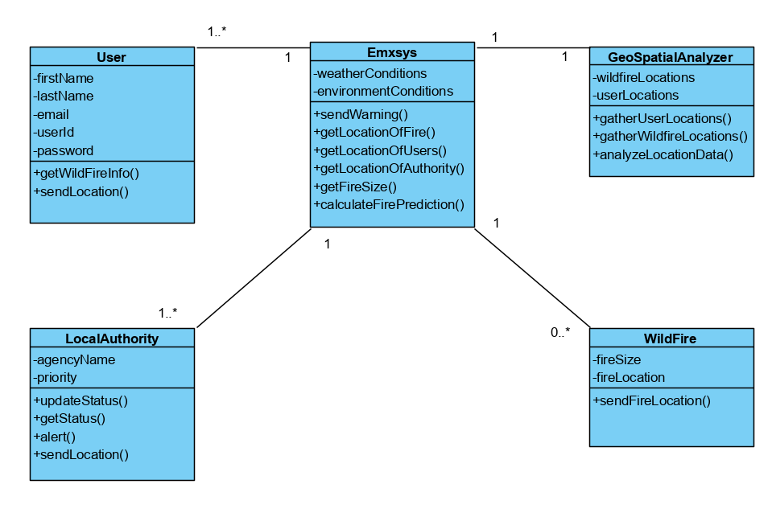

**User:** Represents users registered with the Emxsys. The user has a function to send its location to the Emxsys so that the system can correctly notify users in wildfire hazard areas of their danger.

**LocalAuthority:** Represents local officials that have a duty to alert local workers and residents of wildfires. Can alert the Emxsys to alert users of additional hazards the Emxsys has not handled.

**Emxsys:** The system that collects and directs appropriate information about users and wildfires to affected locations.

**GeoSpatialAnalyzer:** Interprets data about wildfire and user locations to help assess the overall wildfire threat to users.

**WildFire:** Represents the wildfire hazard. Has information about the wildfire to aid the Emxsys in making its prediction.

### **Static Structure**

The static structure of the solution consists of an extension to the current application. This will give the application the ability to actively track the users and the local authorities so that they can more effectively be notified if they are in any sort of danger of a wildfire, or if they will be in danger in the near future.

### **Dynamic Behavior**

The dynamic behavior includes the interaction of the Emxsys with the users and the Geolocation Analytics tool. The system must track the locations of the users and the locations of the wildfires. It can then assess the danger that the users may be in, and then can notify them in real-time of the wildfire’s predicted path and a possible emergency plan.

### **Sequence Diagram of How Geolocation Analytics Works**

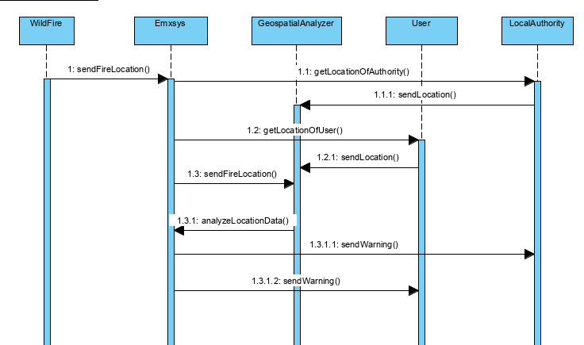

## **Storyboard**

* Title: Emxsys notifies a community of a fire
* Description: In this storyboard, we will observe how Emxsys is used to notify and provide data to a community about a local fire.
* Cast of Characters:
  + Jim: A local farmer and Emxsys user.
  + Lisa: A dispatcher that is notified by Emxsys and sends information to authorities.
  + Sarah: An elderly homeowner. She does not use Emxsys.
  + Mike: A local farmer. He does not use Emxsys.

Emxsys uses the WildFire feature to observe a rural community for any developments in a wildfire prone area. One day, the WildFire feature notices an impending fire hazard near the community.

Emxsys uses the WildFire prediction to notify Lisa, a dispatcher for the local authorities. Lisa is then able to take the data given to her by Emxsys and forward it to the local firefighters to help them predict where a fire could start and minimize the damage of any possible wildfires, saving lives and preventing property damage.

At the same time Jim, a local farmer and a user of Emxsys, is also notified of an impending risk of a wildfire. He is able to use the Geo Spatial Analyzer to help explain the risk and impact of the impending situation easily to himself, his family, and his neighbors and is armed with information necessary to prepare his family and his property. He uses the time gained from the wildfire prediction to move his expensive farm equipment to a safer location and evacuates his family to safety, grateful for the warning from Emxsys.

On the other hand Sarah, a homeowner close to the wildfire danger zone, does not use Emxsys. She is unaware of the situation and continues on with her day. Quickly, a wildfire develops and she gets notified by her local authorities using the information provided by Emxsys. She uses the warning as a chance to evacuate herself and her valuables. Thankful for the warning from the authorities but worried that she was not prepared for the situation herself.

Lastly Mike, another farmer close to the wildfire danger zone, does not use Emxsys. He is unaware of the situation and continues on with his work, business as usual. He is also unable to be reached by his authorities. The smoke gets too close to his property until Mike begins to notice. He panics and uses what little time he has to gather his family and his most essential valuables before he evacuates. In doing so, he suffers property damage that could have been avoided if he was aware.

After the fire is dealt with and the community attempts to return to normalcy, the impact of Emxsys becomes apparent. Jim is very happy with the money he was able to save from being prepared and aware of the situation and recommends it to all of his friends and neighbors. Sarah is also relieved from her successful evacuation and learns of the help of Emxsys through the community. She is older and not very technically proficient but she uses a friend to help her access Emxsys. She uses it to the best of her ability and with the help of the customer support but even if she is not comfortable using it, the local authorities are still using it and have her protected. Finally, Mike is disappointed with the losses he suffered in the fire and wishes he was better prepared. He finds out that other community members like Jim were using Emxsys to notify them and quickly becomes a user to protect himself and prevent another loss.

Through this situation, Emxsys is able to aid its users and the local authorities to protect themselves and minimize damage. The situation also spreads awareness of the usefulness of the app to the community members, helping Emxsys gain many new users.

## **Functional Requirements**

* Most essential requirements

** Most essential requirements

1. (*) System must provide users with up to date wildfire information
2. (**) System must deliver complicated information in a user friendly format
3. (*) System must track data from all over the world and calculate the data for wildfire possibilities
4. (*) System must track user information to better serve customers
5. System should successfully notify users accurately and in a timely manner in case of emergency
6. System should provide an easy avenue to support and help for difficulties

## **Actors**

|  |  |
| --- | --- |
| Actor | Description |
| User | A civilian who uses Emxsys to help them prepare and understand local wildfires. |
| Local Authority | A local authority (firefighter, dispatcher, etc.) in charge of the protection of their jurisdiction. They use Emxsys most intensively to help them predict any upcoming wildfires and help protect citizens. |
| Customer Support | An employee of Emxsys who provides support to users of Emxsys. They help users learn to use Emxsys and provide any help with problems. |
| Market Researcher | An employee of Emxsys whose job it is to research new strategies to increase Emxsys adoption. They look at trends in data and see if there's any pathways to improve adoption or general user experience. |

## **Use Cases, Scenarios, User Stories**

* + 1. **Emxsys Notifies a User and Local Authority**

**3.8.1.1 Functional Objectives:** 1, 2, 3, 5

**3.8.1.2 Description:** In this a user and local authority enter their location and receive information about possible wildfires.

**3.8.1.3 Scenario: The Alert Process**

|  |  |
| --- | --- |
| **Actors** | User, Local Authority |
| **Assumptions** | * The user and local authority have devices to access the service |
| **Happy Path** | 1. User/ local authority enters their location to check wildfire data 2. Data is shown 3. Data can be used to predict upcoming wildfires 4. Users/ local authority use data to help prepare themselves/ community for wildfire |
| **Error Path** | 1. The user/ local authority does not have their location entered 2. The user/ local authority does not check their device for information 3. The local authority fails to report status to citizens |
| **Outcomes** | * The system notifies user/ local authority of impending wildfires * The local authority successfully notifies citizens of impending wildfires |

**3.8.1.3.1 Associated User Stories**

|  |  |  |  |
| --- | --- | --- | --- |
| ID | As a/an | I want to.. | So that.. |
| 1 | User | Enter my location and receive wildfire data in an easy to understand manner | I can prepare myself for any incoming wildfires |
| 2 | Local Authority | Enter my location and receive detailed information to monitor and predict wildfire patterns | I can protect and warn the citizens of my local jurisdiction |

* + 1. **Market Researchers Looks at Trends in Data**

**3.8.2.1 Functional Objectives:** 4

**3.8.2.2 Description:** A market researcher looks at user data to determine where the user base can be expanded and where marketing can be improved.

**3.8.2.3 Scenario: Market Researcher Looks at Trends in Data**

|  |  |
| --- | --- |
| **Actors** | Market Researcher |
| **Assumptions** | * There is a large enough user base to base data off of |
| **Happy Path** | 1. Market Researcher accesses user data\ 2. Shown trends and charts of data 3. Researcher can analyze where user base is most dense and the usage of each user |
| **Error Path** | 1. There is no user base to analyze |
| **Outcomes** | * The company can develop new marketing strategies with the knowledge received from market research |

**3.8.2.3.1 Associated User Stories**

|  |  |  |  |
| --- | --- | --- | --- |
| ID | As a/an | I want to.. | So that.. |
| 3 | Market Researcher | Keep track of where the user base is mostly located | I can judge where the user bas needs to improve as well as analyze what kind of communities are most likely to use this service |
| 4 | Market Researcher | Ask users how they found the service | I can find the most popular method of recommendation for the service as well as develop different methods of marketing |

* + 1. **Customer Support Provides Support to Users**

**3.8.3.1 Functional Objectives:** 6

**3.8.3.2 Description:** Customer support can be used to educate users on

how to correctly and efficiently use the service as well as provide help

**3.8.3.3 Scenario: Customer Support Provides Support to Users**

|  |  |
| --- | --- |
| **Actors** | Customer Support, User |
| **Assumptions** | * Customer support is knowledgeable enough about the service to provide accurate help |
| **Happy Path** | 1. User needs help with the service 2. User visits the customer support portal    1. User can watch tutorials to help themselves figure out their issue 3. User contacts a support representative 4. Customer support provides help until customer is satisfied |
| **Error Path** | 1. The user cannot find the support portal 2. The support is not helpful to the customer |
| **Outcomes** | * User experience is improved by providing support to help users understand complicated wildfire data |

**3.8.3.3.1 Associated User Stories**

|  |  |  |  |
| --- | --- | --- | --- |
| ID | As a/an | I want to.. | So that.. |
| 5 | User | Have a knowledgeable and thorough support portal | I can get help when I am confused or have a problem with the service |
| 6 | Customer Support Representative | Provide knowledgeable support to customers | I can successfully help customers with any issue while improving customer satisfaction |

## **Use Cases, Scenarios, User Stories**

Explains at a high level who is interacting with what system.

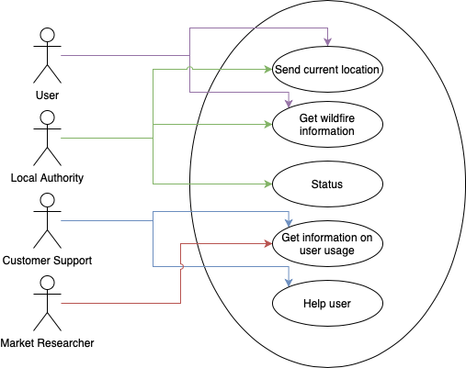

## **Non-Functional Requirements**

Priority is marked by the number in parenthesis. 1 is the highest priority and 3 is the lowest priority.

* + 1. **Availability**

1. (1) The system must be available 24/7 since it is an emergency platform.
2. (1) Customer support must be available 24/7 since it is an emergency system and users might need support for an emergency at any time.
3. (1) All issues must be identified immediately.
   * 1. **Modifiability/Scalability**
4. (3) System should be able to handle thousands of users interacting with the system at once from different locations, but the likelihood of multiple catastrophic wildfires happening concurrently are low but not impossibly.
5. (3) System should support the ability to add tutorials.
   * 1. **Performance**
6. (2) System should be able to handle collecting data on thousands of concurrent users without slowing down the system.
7. (1) System should be able to handle multiple wildfires at once.
   * 1. **Security**
8. (1) Keep user information private.
9. (1) System should be secure enough to prevent malicious users from altering wildfire information.
10. (1) System should not allow malicious users access to location services.
    * 1. **Testability**
11. (2) System should log all unique requests made within 30 seconds.
    * 1. **Usability**
12. (1) Easy to use interface since users most likely will not be tech savvy.

## **Acceptance Plan**

* All functional requirements in the released system must pass acceptance testing
* Availability:
  + System must be available 24/7.
  + Customer support must be available 24/7 to support users with any issues.
  + Test with:
    - 1000 concurrent users
    - Multiple regions
  + All issues must be identified immediately
  + Test with:
    - All regular and boundary issues.
* Modifiability/Scalability:
  + System should be able to handle thousands of users interacting with the system at once from different locations.
  + Test with:
    - Thousands of users all in different locations
    - All making concurrent requests
  + System should support the addition of tutorials
  + Test with:
    - A new tutorial being added every week
* Performance:
  + System should be able to handle collecting data on thousands of concurrent users without slowing down the system.
  + Test with:
    - 10,000 different users from different locations all interacting with systems. Specifically location services.
  + System should be able to handle multiple wildfires at once.
  + Test with:
    - Multiple simulated wildfires.
* Security:
  + Keep user information private.
  + System should be secure enough to prevent malicious users from altering wildfire information.
  + System should not allow malicious users access to location services.
  + Test with:
    - 100 ethical hackers.
* Testability
  + System should log all unique requests made within 30 seconds.
  + Test with:
    - 1000 cases
* Usability
  + Easy to use interface since users most likely will not be tech savvy.
  + Test with:
    - 20 users, all of varying technical ability

# **Architecture**

## **Overview**

The architecture takes what was covered in the other sections and uses them as a guide to build out how our system shall work and operate

## **Subsystem Model**

This shows the various logical systems that all communicate to make the system as a whole function.

4.2.1 Wildfire Management System

Four subsystems comprise this system (Wildfire Locator, User Locator, Wildfire Prediction, User Warning) that all work together to properly inform users of predicted wildfire behavior.

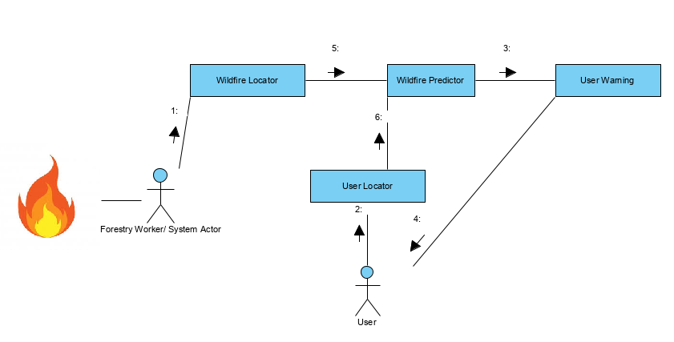

|  |  |
| --- | --- |
| Name | Wildfire Locator |
| Description | This subsystem is activated when a wildfire is identified by and reported by a user of the subsystem. |
| Meet FR | 1, 3, 6 |
| Meet NFRs | 1.1) System is available 24/7 for reporting.  1.3) Any issues involved with locating wildfires must be dealt with immediately.  3.2) System should be able to handle reporting multiple wildfires.  4.3) Wildfires must be verified by credible source or multiple users for accurate data collection. |
| Quality Scenarios | The user locates a wildfire, reports it to the system, and the system will register the fire. |

|  |  |
| --- | --- |
| Name | User Locator |
| Description | This subsystem is activated when a user identifies their location through the system |
| Meet FR | 1, 2, 4, 6 |
| Meet NFRs | 1.1) System is available 24/7 for reporting.  1.3) Any issues involved with locating users must be dealt with immediately.  2.1) System should be able to handle reporting multiple users.  4.1) Location data of users will be kept private.  4.3) User data will not be available for malicious use. |
| Quality Scenarios | The user sends their location data to the system and the system logs the user locations |

Wildfire Predictor Sequence Diagram

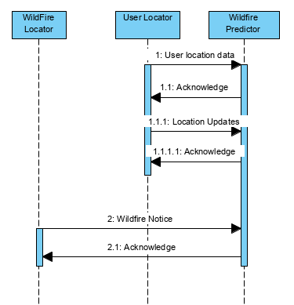

|  |  |
| --- | --- |
| Name | Wildfire Predictor |
| Description | This subsystem is activated when a wildfire is reported. Data is analyzed here to determine the wildfire prediction and appropriately notify any stakeholder. |
| Meet FR | 3, 4, 6 |
| Meet NFRs | 1.1) System is available 24/7 for reporting.  1.2) Any issues involved with analyzing wildfires must be dealt with immediately.  1.3) All analyzing issues will be fixed immediately  2.3) System will be able to handle all users.  3.1) System will allow all users to access data and will analyze any user updates to location data.  4.2) Data will not be maliciously manipulated to alter the analyzer.  5.4) All data will be logged within 30 seconds |
| Quality Scenarios | The user locates a wildfire, reports it to the system, and the system will register the fire. |

User Warning Sequence Diagram

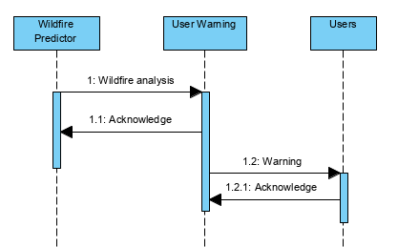

|  |  |
| --- | --- |
| Name | User Warning |
| Description | This subsystem is activated when the wildfire and user data is analyzed so that the system can make accurate warnings so that the users can take safety precautions from the wildfires. |
| Meet FR | 1, 2, 5, 6 |
| Meet NFRs | 1.1) System is available 24/7 for warnings.  1.2) Any issues involved with warning users must be dealt with immediately.  1.3) All warning issues will be fixed immediately  2.3) System will be able to handle all users.  3.1) System will allow all users to access data and will analyze any user updates to location data.  4.2) Data will not be maliciously manipulated to alter the warnings.  5.4) All data will be logged within 30 seconds |
| Quality Scenarios | The wildfire data and user data are analyzed to produce warnings for the appropriate users so that they can take precautions against wildfires |

## **Target Environment**

### **Deployment Diagram**

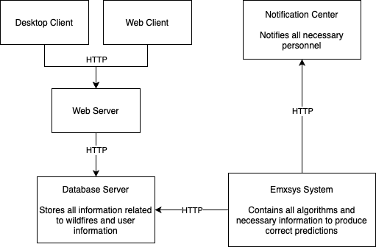

### **Explanation of Components in Deployment Diagram**

|  |  |
| --- | --- |
| Name | Desktop Client & Web Client |
| Description | The outward facing system that allows users to interact with the Emxsys system. |
| Meet FR | 1, 2, 6 |
| Meet NFRs | 1.1) The system must be available 24/7 since it is an emergency platform.  1.2) Customer support must be available 24/7 since it is an emergency system and users might need support for an emergency at any time.  2.1) System should be able to handle thousands of users interacting with the system at once from different locations, but the likelihood of multiple catastrophic wildfires happening concurrently are low but not impossibly.  2.2) System should support the ability to add tutorials.  3.1) System should be able to handle collecting data on thousands of concurrent users without slowing down the system.  3.2) System should be able to handle multiple wildfires at once.  5.1) System should log all unique requests made within 30 seconds.  6.1) Easy to use interface since users most likely will not be tech savvy. |
| Quality Scenarios | The users can interact with the system however they want. The system will process all requests properly without failure. Users are able to interact with customer support in order to fix their issues. |

|  |  |
| --- | --- |
| Name | Web Server |
| Description | This handles all user requests and determines what is the proper action that needs to happen. It also provides the current information to the database. |
| Meet FR | 1, 3, 4, 6 |
| Meet NFRs | 1.1) The system must be available 24/7 since it is an emergency platform.  3.1) System should be able to handle collecting data on thousands of concurrent users without slowing down the system.  3.2) System should be able to handle multiple wildfires at once.  4.1) Keep user information private.  4.2) System should be secure enough to prevent malicious users from altering wildfire information.  4.3) System should not allow malicious users access to location services.  5.1) System should log all unique requests made within 30 seconds. |
| Quality Scenarios | The web server will be able to handle the maximum number of concurrent requests and users as allowed. All data provided to the database is correct and in the proper format. |

|  |  |
| --- | --- |
| Name | Database Server |
| Description | The server that holds all of the data for the Emxsys system. |
| Meet FR | 3, 4 |
| Meet NFRs | 1.1) The system must be available 24/7 since it is an emergency platform.  2.1) System should be able to handle thousands of users interacting with the system at once from different locations, but the likelihood of multiple catastrophic wildfires happening concurrently are low but not impossibly.  4.1) Keep user information private.  4.2) System should be secure enough to prevent malicious users from altering wildfire information.  4.3) System should not allow malicious users access to location services.  5.1) System should log all unique requests made within 30 seconds. |
| Quality Scenarios | All data provided to the users is in the correct format and is encrypted. Users can only access the data that is allowed for the correct profile type. |

|  |  |
| --- | --- |
| Name | Emxsys System |
| Description | The backend system that provides all of the algorithms for correct and timely predictions. |
| Meet FR | 3, 5 |
| Meet NFRs | 1.1) The system must be available 24/7 since it is an emergency platform.  1.3) All issues must be identified immediately.  2.1) System should be able to handle thousands of users interacting with the system at once from different locations, but the likelihood of multiple catastrophic wildfires happening concurrently are low but not impossibly.  3.1) System should be able to handle collecting data on thousands of concurrent users without slowing down the system.  3.2) System should be able to handle multiple wildfires at once.  5.1) System should log all unique requests made within 30 seconds. |
| Quality Scenarios | Correct notifications are sent out immediately for any critical situations. All predictions are properly updated with the influx of new data. The algorithms are maintained and checked for correctness. |

|  |  |
| --- | --- |
| Name | Notification Center |
| Description | The place for all notifications held in one central location. |
| Meet FR | 2, 5 |
| Meet NFRs | 1.1) The system must be available 24/7 since it is an emergency platform.  1.3) All issues must be identified immediately.  3.2) System should be able to handle multiple wildfires at once.  4.1) Keep user information private.  4.2) System should be secure enough to prevent malicious users from altering wildfire information.  4.3) System should not allow malicious users access to location services.  6.1) Easy to use interface since users most likely will not be tech savvy. |
| Quality Scenarios | All notifications are stored for all users here. New notifications are sent out and users are alerted of any possible wildfires. |

# **Project Planning**

## **Release Plan**

* Release 1 (release date September 14th, 2020)
  + Update and optimize the current Emxsys software
    - Make the look and feel more user-friendly, etc.
  + Create a basic customer support portal
  + Set up a notification system for desktop version
  + Reach agreements with local authorities to secure usage and deals
  + Start advertising to increase user base
* Release 2 (release date January 11th, 2021)
  + Add tutorials to customer support portal
  + Make changes based on marketing information, user usage, and feedback
  + Distribute a mobile version of the application
* Release 3 (release date March 1st, 2021)
  + Improve mobile application based on feedback, marketing data
  + Release optimized notification and warning system
    - Location based warnings based on user
    - Impending weather/fire conditions
    - Local Authority updates and information
    - Fire Damage predictions

## **Project Estimation**

### **Linear Estimate**

|  |  |
| --- | --- |
| **Tasks and their estimated efforts (hours)** | |
| **Task** | **Effort(hours)** |
| User Interface Update | 150 |
| Customer Support Portal | 140 |
| Desktop Notification System | 100 |
| Reach deals with local authorities | 120 |
| Ramp up advertising | 70 |
| Test functionality of Release 1 | 50 |
| Add tutorials to customer support portal | 200 |
| Improve functionality per feedback, marketing data | 40 |
| Create and distribute mobile version | 500 |
| Test functionality of Release 2 | 80 |
| Improve mobile version per feedback, marketing data | 60 |
| Optimize notification system | 190 |
| Location specific real-time notifications | 70 |
| Weather/fire conditions | 60 |
| Local authority updates and information | 50 |
| Fire damage predictor | 80 |
| Testing functionality of Release 3 | 50 |
| **Total** | 2020 |

### **Use Case Points Estimate**

|  |  |  |
| --- | --- | --- |
| **Actors** | | |
| **Actors** | **Actor Type** | **Weighing Factor** |
| User | Complex | 3 |
| Local Authority | Complex | 3 |
| Customer Support | Complex | 3 |
| Market Researcher | Complex | 3 |
|  | **Unadjusted Actor Weights (UAW)** | 12 |

|  |  |  |
| --- | --- | --- |
| **Use Cases** | | |
| **Use Case** | **Use Case Type** | **Weighing Factor** |
| User Interface Update | Complex | 3 |
| Customer Support Portal | Complex | 3 |
| Desktop Notification System | Average | 2 |
| Reach deals with local authorities | Complex | 3 |
| Ramp up advertising | Complex | 3 |
| Test functionality of Release 1 | Average | 2 |
| Add tutorials to customer support portal | Complex | 3 |
| Improve functionality per feedback, marketing data | Average | 2 |
| Create and distribute mobile version | Complex | 3 |
| Test functionality of Release 2 | Average | 2 |
| Improve mobile version per feedback, marketing data | Average | 2 |
| Optimize notification system | Complex | 3 |
| Location specific real-time notifications | Simple | 1 |
| Weather/fire conditions | Simple | 1 |
| Local authority updates and information | Simple | 1 |
| Fire damage predictor | Average | 2 |
| Testing functionality of Release 3 | Average | 2 |
|  | **Unadjusted Use Case Weights (UUCW)** | 38 |

|  |  |  |  |  |
| --- | --- | --- | --- | --- |
| **Technical Factors** | | | | |
| **Factor** | **Description** | **Value(0-5)** | **Weight** | **Product** |
| T1 | Distributed system | 2 | 2 | 4 |
| T2 | Response time/performance objectives | 2 | 1 | 2 |
| T3 | End-user efficiency | 3 | 2 | 6 |
| T4 | Internal processing complexity | 1 | 1 | 1 |
| T5 | Code reusability | 3 | 2 | 6 |
| T6 | Easy to install | 3 | 1 | 3 |
| T7 | Easy to use | 4 | 2 | 8 |
| T8 | Portability to other platforms | 2 | 1 | 2 |
| T9 | System maintenance | 4 | 1 | 4 |
| T10 | Concurrent/parallel processing | 0 | 0.5 | 0 |
| T11 | Security features | 1 | 1 | 1 |
| T12 | Access for third parties | 2 | 2 | 4 |
| T13 | End user training | 5 | 2 | 10 |
|  | **Technical Complexity Factor (TCF)** | **1.11** |  |  |

|  |  |  |  |  |
| --- | --- | --- | --- | --- |
| **Environmental Factors** | | | | |
| **Factor** | **Description** | **Value(0-5)** | **Weight** | **Product** |
| E1 | Familiarity with Dev process used | 0 | 0.5 | 0 |
| E2 | Application experience | 3 | 1 | 3 |
| E3 | Object-oriented experience of team | 2 | 1 | 2 |
| E4 | Internal processing complexity | 1 | 1 | 1 |
| E5 | Motivation of the team | 4 | 2 | 8 |
| E6 | Stability of requirements | 3 | 2 | 6 |
| E7 | Part-time staff | 3 | 1 | 3 |
| E8 | Difficult programming language | 0 | 0.5 | 0 |
|  | **Environmental Factor (EF)** | **0.71** |  |  |
|  | **Adjusted Use Case Points (UPC)** | **39.405** |  |  |
|  | **Total Estimate (UPC * 30 hrs/pt)** | **1182.15** |  |  |

### **Comparison**

For the linear estimate, the time requirements were given fairly generously because of the nature and scope of the problem. We felt that it would be best for the estimates to be generous considering the open source nature of the platform and the large amount of changes to be had for the project. With the tremendous task in front of us, we felt it appropriate to leave a large amount of time for any problems along the way. The total estimate for this method was 2,020 hours.

For the use case point estimate, the general guidelines for the use case points estimation technique were used. For these estimates we used generous amounts again to give a fair amount of padding. For this estimate the total was 1,182 hours.

The difference in hours between these two methods is very large. Given the huge disparity, we felt it safer to go with the linear estimate. Although the use case estimate was much more detailed, the extra time for this given project feels like a better fit considering the size of the task.

## **Project Schedule**

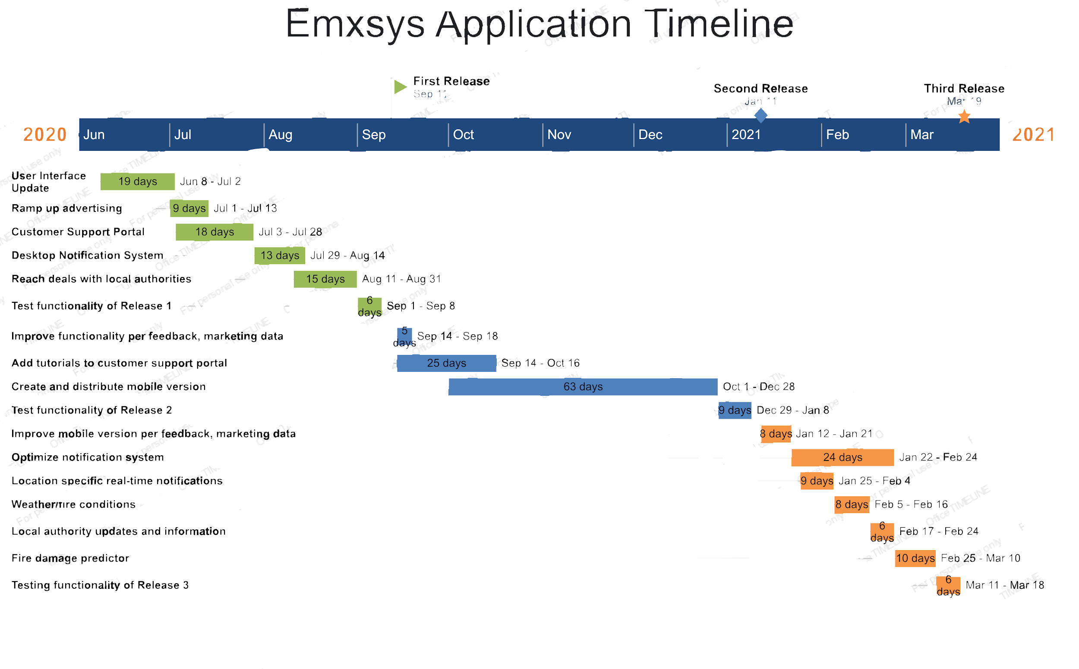

## **First Release**

* Functional Requirements
  + System must provide users with up to date wildfire information
  + System must deliver complicated information in a user friendly format
  + System must track user information to better serve customers
  + System should provide an easy avenue to support and help for difficulties
  + System should successfully notify users accurately and in a timely manner in case of emergency
* Non-Functional Requirements
  + System is available 24/7 for reporting.
  + Keep user information private
  + System should not allow malicious users access to location services
  + System should log all unique requests made within 30 seconds.
  + Easy to use interface since users most likely will not be tech savvy

## **Risk Management Plan**

|  |  |  |  |  |
| --- | --- | --- | --- | --- |
| **Risk** | **Impact** | **Transition Indicator** | **Mitigation** | **Containment** |
| Low adoption from local authorities/ a lack of deals or agreements | Less income from lack of adoption  Less budget for development | Large amount of contacted government agencies do not agree to use the product | Increase awareness of the usefulness of the project to government authorities | Reduce operating costs to cover for lack of adoption  Hold a meeting to design a new strategy to increase adoption |
| Lack of Open Source Developers | Less expertise from a wide range of volunteer developers  Have to invest more into salaried developers  Project loses valuable open source style of development | Less open source developers begin to submit changes to the project | Improve benefits for open source developers, make it a project worthy of continuing to volunteer for  Break the project into parts so that goals are more easily attainable by the scattered team | Hire more developers so there is a committed staff  Spread the word of the project more so that more volunteers may join |